

Database Design & Development
10204282
A/618/7400

Section (5)

Submitted to
Hala AbuSalah

Submitted by
Nour Atiya

Fall –2025-2026

Table of Contents
1 Database Requirement 2
1.1 Scenario (Introduction) 2
1.2 Data Requirements 3
1.3 User Roles and Privileges 3
1.4 System Requirement 4
1.5 Functional and nonfunctional requirements 4
2 Database Design 5
2.1 Conceptual Design 5
2.1.1 Definition 5
2.1.2 Objective 5
2.1.3 Components 5
2.1.4 Conceptual Design Diagram 5
2.2 Schema and Mapping 6
2.2.1 My attributed with their types 6
2.2.2 Step1: Mapping of Regular (strong) Entity Types 7
2.2.3 Step2: Mapping of Weak Entity Types 8
2.2.4 Step3: Mapping of (1:1) Relation types 8
2.2.5 Step4: Mapping of (1:M) Relation types 8
2.2.6 Step5: Mapping of (M: N) Relation types 9
2.2.7 Final schema 9
2.3 Normalization 10
2.3.1 1st NF 10
2.3.2 2nd NF 10
2.3.3 3rd NF 11
2.3.4 Logical Design 12
2.3.5 Physical Design 13
2.3.6 Effectiveness of the design 15
References 16

Database Requirement

Scenario (Introduction)
You are working as a Junior Database Developer at FutureTech Innovations, a company that supports digital government services in Jordan. Currently, FutureTech Innovations is working on a system related to SANAD, the national digital services platform.
SANAD provides online government services, including Personal Identification Card Renewal, which allows citizens to renew their personal identification cards electronically. The system collects citizen information such as National ID number, personal details, uploaded documents, and payment records. It also tracks service requests and their approval status.
The database system is required to store citizen data securely, manage renewal requests, process payments, and track request status updates. Additionally, the system allows authorized government employees to review applications, approve requests, and maintain accurate records to ensure transparency and accountability.

Data Requirements
Data requirements define the data entities, attributes, and relationships required to support system functionality.
- Citizen Data Requirements
- The system shall store citizen data National ID.
- The system should store citizen information and should include full name, birth date, and address details (country, city, street name).
- The system should store contact information such as phone numbers and email addresses should be stored for communication purposes.
- Employee Data Requirements
- The system should store employee data Employee ID.
- Employee information should include first name, last name, job role, and email address.
- An employee may be responsible for processing multiple service requests.
- Service Request Data Requirements
- The system shall store service request data by RequestID.
- Each service request shall be linked to one CitizenID and one EmployeeID.
- Request data shall include submission date and request status.
- Request status shall be used to track the progress of the request (Pending, Under Review, Approved, Rejected, Completed).
- Payment Data Requirements
- The system shall store payment data by PaymentID.
- Each service request may have multiple payment records, while each payment recordis linked to one service request.
- Payment information shall include amount paid, payment method, payment date, and payment status.
- A service request shall not be considered completed unless a valid payment record exists.

User Roles and Privileges
User requirements describe what end users expect from the SANAD Personal Identification Card Renewal system. These requirements are written in non-technical language and focus on user goals and interactions.
- Citizen Requirements
- The citizens should be able to register and log in using their CitizenID.
- The citizens should be able to view and update their personal information.
- The citizen should be able to submit a personal ID renewal request online.
- The citizens should be able to upload required documents.
- The citizens should be able to complete payment for the request.
- The citizens should be able to track the request status (pending, approved).
- The citizens should be able to view previously submitted requests.
- Employee Requirements

- The employee should be able to log in to the system using authorized credentials.
- The employee should be able to view assigned service requests.
- The employee should be able to review citizen information, upload documents, and payment details.
- The employee should be able to update the request status (under review, approved, rejected).
- The employee should be able to record actions taken on each request for accountability purposes.

- Administrator’s Requirements

- The administrator should have full access to all system functions.
- The administrator should be able to manage citizen, employee, service, and request records.
- The administrator should be able to manage user & employee roles and access permissions.
- The administrator should be able to generate system and service reports.

- Service Auditor
- The service auditor should be able to log in to the system using authorized credentials.
- The service auditor should be able to view all submitted service requests.
- The service auditor should be able to generate audit reports for service requests, including request status, payment confirmation, and employee actions.
- The service auditor should be able to track changes and updates made by employees to service requests.
- The service auditor should have read-only access and should not be able to modify service requests or citizen data.

System Requirement
- The system shall store all citizens, employees, service requests, and payments in a relational database with up-to-date records.
- The system shall automatically update the service request status when actions are performed by authorized employees.
- The system shall validate payment completion before allowing a service request to move to the completed status.
- The system shall associate each service request with a responsible employee for processing and accountability.
- The system shall prevent duplicate service requests for the same citizen when a previous request is still active.
- The system shall ensure data consistency between service requests and payment records.
- The system shall record the latest status and update time for each service request.
- The system shall restrict data access based on assigned system roles.
- The system shall support secure storage of citizen and payment information.
- The system shall generate system-level reports related to requests and payments.

Functional and nonfunctional requirements
- Functional Requirements
- The system shall allow citizens to register and log in using their national ID.
- The system shall allow citizens to view and update their personal information.
- The system shall allow citizens to submit a personal identification card renewal request.
- The system shall allow citizens to upload required documents for the request.
- The system shall allow citizens to make payments related to their service requests.
- The system shall record payment details linked to the service request.
- The system shall allow employees to view assigned service requests.
- The system shall allow employees to review citizen information and documents.
- The system shall allow employees to update the service request status (pending, approved, rejected).
- The system shall allow administrators to manage citizens, employees, requests, and payments.
- The system shall allow administrators to generate reports related to service requests and payments.
- Non-Functional Requirements
- The system shall respond to user requests within 2 seconds under normal operating conditions.
- The system shall ensure data consistency and accuracy across all related tables.
- The system shall restrict access to sensitive data to authorized users only.
- The system shall securely store sensitive citizen and payment data.
- The system shall support multiple concurrent users without performance degradation.
- The system should maintain 99% system availability, excluding scheduled maintenance.
- The system shall prevent unauthorized modification of service request data.
- The system shall maintain reliable records without data loss during normal operation.
- The system shall allow maintenance and updates with minimal downtime.

Database Design

Conceptual Design

Definition
The conceptual design phase defines what data the system will store and how it relates, independent of any technical or physical considerations. Its main goal is to model the system at a high level to reflect the real-world requirements of users and the organization. It identifies entities, relationships, and key attributes, ensuring the system accurately represents the business domain. This design serves as a foundation for the logical and physical designs that follow.

Objective
It aims to:
- define the structure and scope of the data.
- Identify key data elements and their relationships.
- Ensure alignment with organizational objectives and user needs.
- Provide a basis for subsequent logical and physical database designs.

Components
- Entities: These are the primary objects or concepts about which data is stored. In my system (Citizen/ Service Request/ Employee/ Payment)
- Relationships: Properties or characteristics of the entities. (Citizens can submit multiple Service Requests (1: many))
- Attributes: Each entity has key attributes that uniquely identify it and store necessary information (Citizen: National ID, full name, date of birth, gender, contact details.)

Conceptual Design Diagram
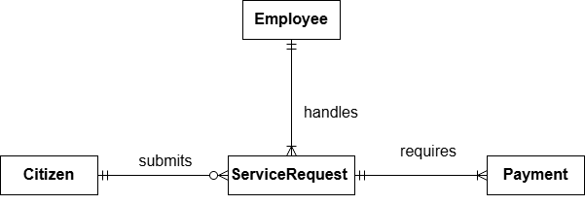

The conceptual design provides an overview of the entities and relationships in this database. For example, Citizen and ServiceRequest share a (1: M) relationship, so that one citizen can submit multiple service requests. Similarly, Employees and ServiceRequests are connected via an (1: M) relationship meaning that at any point in time, one ServiceRequest is assigned to one Employee, and Employee can handle many ServiceRequests. Finally, ServiceRequest and Payment have a (1:M) relationship, where a single service request may be associated with multiple payment records, while each payment belongs to exactly one service request. These relationships collectively ensure accurate representation of system interactions and maintain data integrity throughout the platform.

Schema and Mapping

My attributed with their types
- Citizen
(CitizenID (PK), FullName, DateOfBirth, Gender, Nationality, PhoneNumber, Email, Address)
- ServiceRequest
(RequestID (PK), CitizenID (FK), EmployeeID (FK), SubmissionDate, RequestStatus, ProgressStage)
- Employee
(EmployeeID (PK), FullName, JobRole, PhoneNumber, Email)
- Payment
(PaymentID (PK), RequestID (FK), AmountPaid, PaymentMethod, PaymentDate, PaymentStatus)
Entity 1: Citizen
Attribute | Type | Description
CitizenID (PK) | Simple, Single-valued | Unique identifier for the citizen
FullName | Composite | It consists of first name, middle name, and last name
DateOfBirth | Simple, Single-valued | Date of birth of the citizen
Gender | Simple, Single-valued | Gender of the citizen
Nationality | Simple, Single-valued | Nationality of the citizen
PhoneNumber | Multivalued | A citizen may have multiple phone numbers
Email | Simple, Single-valued | Email address of the citizen
Address | Composite | Includes country, city, and street name
Age | Derived | Age of the citizen (derived from DateOfBirth)

Entity 2: ServiceRequest
Attribute | Type | Description
RequestID (PK) | Simple, Single-valued | Unique identifier for the service request
CitizenID (FK) | Simple, Single-valued | References to the citizen who submitted the request
EmployeeID  (FK) | Simple, Single-valued | References to the requested service
SubmissionDate | Simple, Single-valued | Date when the request was submitted
RequestStatus | Simple, Single-valued | Status of the request (e.g., pending, approved, rejected)
Entity 3: Employee
Attribute | Type | Description
EmployeeID (PK) | Simple, Single-valued | Unique identifier for the employee
FullName | Composite | It consists of first name, middle name, and last name
JobRole | Simple, Single-valued | Job role or position of the employee
PhoneNumber | Multivalued | An employee may have multiple phone numbers
Email | Simple, Single-valued | Email address of the employee
Entity 4: Payment
Attribute | Type | Description
PaymentID (PK) | Simple, Single-valued | Unique identifier for the payment
RequestID (FK) | Simple, Single-valued | References regarding the related service request
AmountPaid | Simple, Single-valued | Amount paid for the service
PaymentMethod | Simple, Single-valued | Method used for payment (e.g., card, e-wallet)
PaymentDate | Simple, Single-valued | Date when the payment was made
PaymentStatus | Simple, Single-valued | Status of payment (completed, pending, failed)

Step1: Mapping of Regular (strong) Entity Types
In step 1, the strong entities are mapped by resolving composite attributes into simpler attributes. Any multi-valued attributes are extracted into separate tables, and derived attributes are removed.
- Citizen (CitizenID, Citizen First Name, Citizen Last Name, Date of Birth, Gender, Nationality, Email, Country, City, Street Name)
- Full Name (composite) → split into First Name and Last Name
- Address (composite) → split into Country, City, Street Name
- Phone Number (multi-valued) → moved to a separate table
- Age (derived) → removed
Citizen Phone (CitizenID, Phone Number)
- Service Request (Request ID, Submission Date, Request Status, CitizenID, Employee ID)
- All attributes are simple and single-valued
- CitizenID and EmployeeID are included to represent the relationships with Citizen and Employee
- Employee (Employee ID, Employee First Name, Employee Last Name, Job Role, Email)
- Full Name (composite) → split into First Name and Last Name
- Phone Number (multi-valued) → moved to a separate table
Employee Phone (Employee ID, Phone Number)

- Payment (Payment ID, Amount Paid, Payment Method, Payment Date, Payment Status, RequestID)
- All attributes are simple and single-valued
- RequestID is included as a foreign key to associate each payment with its corresponding service request

Step2: Mapping of Weak Entity Types
- Phone Number for Employee
Employee Phone (Employee ID, Phone Number)

- Phone Number for Citizen
Citizen Phone (CitizenID, Phone Number)

Step3: Mapping of (1:1) Relation types
- Citizen – Biometric Record (1:1): One citizen is associated with one biometric record, and each biometric record corresponds to one citizen. The CitizenID is add in the Biometric Record table is as FK and unique,
- Citizen (CitizenID, Citizen First Name, Citizen Last Name, Date of Birth, Gender, Nationality, Email, Country, City, Street Name)
- Biometric Record (Biometric ID, CitizenID, Biometric Type, Encrypted Data, Registration Date)

Step4: Mapping of (1:M) Relation types
In (1: M) relationships, the primary key of the one side is added as a foreign key in the many sides.
- Citizen – ServiceRequest (1: M): One citizen can submit many service requests.
The CitizenID is added as an FK in the ServiceRequest table.
- Service Request (Request ID, SubmissionDate, RequestStatus, CitizenID, Service ID)

- Employee – ServiceRequest (1: M): One employee can handle many service requests. The EmployeeID is added as an FK in the ServiceRequest table.
- ServiceRequest (RequestID, SubmissionDate, RequestStatus, CitizenID, EmployeeID)
- ServiceRequest – Payment (1:M): One service request may have multiple payments, while each payment is associated with exactly one service request.
- Payment (Payment ID, Amount Paid, Payment Method, Payment Date, Payment Status, RequestID)

Step5: Mapping of (M: N) Relation types
The many-to-many relationship will be represented as a new table. The primary key of this table will be a combination of the primary keys of the two ends of the relation.
While There is no many to many relationships in my scenario. I’ll use relationship does not mention on my scenario...
Citizen – Fee (M: N): citizen can pay many Fees & Fees can be paid by many Citizens. CitizenID is added as an FK referencing Citizen & FeeID is added as an FK referencing Fee.
- Original Entities (Before Mapping)
- Citizen:
(CitizenID, Citizen First Name, Citizen Last Name, Date of Birth, Gender, Nationality, Email, Country, City, Street Name)
- Fees:
(FeeID, Fee Name, Fee Amount)

- CitizenFees
(CitizenID, FeeID, Payment Date, Payment Status)
. Composite Primary Key: (CitizenID, FeeID)

Final schema
Citizen: (CitizenID, Citizen First Name, Citizen Last Name, Birth Date, Gender, Nationality, Email, Country, City, Street Name)
Citizen Phone: (CitizenID, Phone Number)
Employee: (Employee ID, Employee First Name, Employee Last Name, Job Role, Email)
Employee Phone: (Employee ID, Phone Number)
Service Request: (Request ID, Submission Date, Request Status, Progress Stage, CitizenID, Employee ID)
Payment: (Payment ID, Amount Paid, Payment Method, Payment Date, Payment Status, Request ID)

Normalization

1st NF
- Definition:
A relation is in First Normal Form (1NF) if:
- Each attribute contains atomic (single) values.
- There are no multivalued or repeating attributes.
- Each record can be uniquely identified.
- When 1NF is violated:
when a table contains multivalued attributes, composite attributes that are not decomposed, or repeating groups
Relations | Attributes | Violation Description | Solution — Relations
Citizen  (CitizenID,  FullName, DateOfBirth, Gender, Nationality,  PhoneNumber, Email, Address) | 1) FullName  2) Address  3) Phone  Number  4) age | 1. It is composite it is from two parts, and both are needed separately  2. It is composite it is from two parts, and both are needed separately  3. PhoneNumber is a multivalued attribute.  4. Derived, it could be known from date of birth | Citizen  (CitizenID, FirstName, LastName, DateOfBirth, Gender,  Nationality, Email,  Country, City, StreetName)  CitizenPhone  (CitizenID, PhoneNumber)
Employee  (EmployeeID,  FullName,  JobRole, PhoneNumber, Email) | 1) FullName  2) Phone Number | 1. It is composite it is from two parts, and both are needed separately  2. PhoneNumber is a multivalued attribute. | Employee  (EmployeeID, FirstName,  LastName, JobRole,  Email)  EmployeePhone  (EmployeeID, PhoneNumber)

2nd NF
- Definition:
A relation is in Second Normal Form (2NF) if:
- It is already in 1NF, and
- There are no partial dependencies, meaning every non-key attribute must depend on the entire primary key, not part of it.
- When 2NF is violated:
when a table has a composite primary key and some non-key attributes depend only on part of that key.
Relations | FDs | Violation Description | Solution – Relations
Citizen | CitizenID → (FirstName, LastName, BirthDate, Gender, Nationality, Email, Country, City, StreetName) | No composite key → no partial dependency | Citizens are already in 2NF
CitizenPhone | (CitizenID, PhoneNumber) → PhoneNumber | PhoneNumber depends on full composite key | CitizenPhone is in 2NF
Employee | EmployeeID → (FirstName, LastName, JobRole, Email) | No composite key → no partial dependency | Employee is in 2NF
EmployeePhone | (EmployeeID, PhoneNumber) → PhoneNumber | PhoneNumber depends on full composite key | EmployeePhone is on 2NF
ServiceRequest | RequestID → (SubmissionDate, RequestStatus, ProgressStage, CitizenID, EmployeeID) | Single primary key | ServiceRequest is in 2NF
Payment | PaymentID → (AmountPaid, PaymentMethod, PaymentDate, PaymentStatus, RequestID) | Single primary key | Payment is in 2NF
CitizenFees  (out) | CitizenID → Citizen attributes  FeeID → Fee attributes  (CitizenID, FeeID) → Payment Date, Payment Status | Partial dependency exists because Citizen details depend only on CitizenID and Fee details depend only on FeeID, which are parts of the composite primary key. | Citizen (CitizenID, First Name, Last Name, Birth Date, Gender, Nationality, Email, Country, City, Street Name)  Fee (FeeID, Fee Name, Fee Amount)  CitizenFees (CitizenID, FeeID, Payment Date, Payment Status)

3rd NF
- Definition:
- A relation is in Third Normal Form (3NF) if:
• It is already in Second Normal Form (2NF), and
• There are no transitive dependencies, meaning every non-key attribute must depend only on the primary key and not on another non-key attribute.
- When 3NF is violated:
- 3NF is violated when a non-key attribute depends on another non-key attribute, rather than depending directly on the primary key.
- This creates a transitive dependency, which can lead to data redundancy and update anomalies.

Relations | FDs | Violation Description | Solution – Relations
Citizen | CitizenID → Country, City | City depends on Country (logical hierarchy) but not functionally stored | No transitive dependency affecting keys
Employee | EmployeeID → JobRole | JobRole does not determine other attributes | Employee is in 3NF
ServiceRequest | RequestID → CitizenID → Citizen attributes | Citizen attributes stored in Citizen table | No transitive dependency
Payment | PaymentID → RequestID → CitizenID | Citizen data not stored in Payment | Payment is in 3NF
CitizenFees  (out) | (CitizenID, FeeID) → Payment Date, Payment Method, Payment Status | Previously: transitive dependency via PaymentMethod → PaymentStatus | CitizenFees (CitizenID, FeeID, Payment Date, Payment Method)  PaymentMethod (Payment Method, Payment Status)

Logical Design
- Definition
The logical design defines how the conceptual model is transformed into a structured relational schema. It focuses on organizing the data into well-defined entities, attributes, and relationships while ensuring minimal redundancy and maximum consistency. This design specifies the primary keys to uniquely identifying records, foreign keys to link tables, and associative tables to handle any many-to-many relationships.
- Goals
The main goals of the logical design are:
- Ensure the database structure accurately represents real-world processes and requirements.
- Maintain data integrity and consistency across all tables.
- Minimize redundancy by using a normalized structure.
- Make the database easy to maintain and scalable for future needs.
- Prepare a clear blueprint for physical implementation of the database.
- Components
- Entities
- Attributes
- Relationships

MY Logical Design
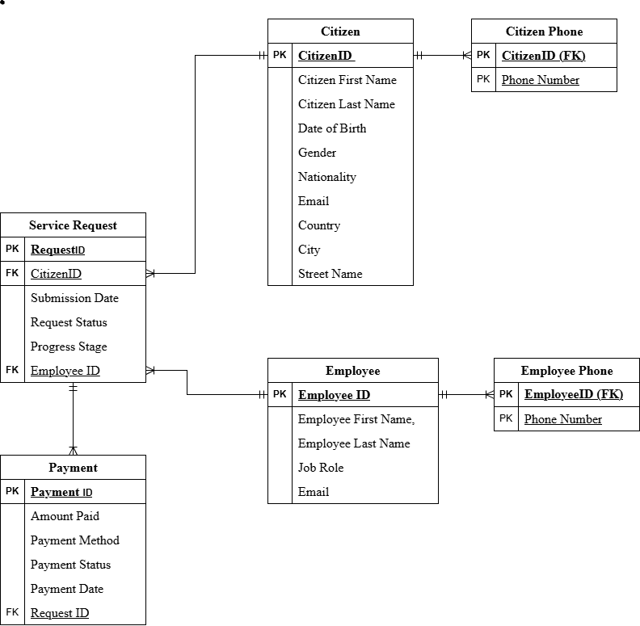
Above is the logical design that presents all entities of the database along with their attributes, primary keys, foreign keys, and the relationships among them. The relationship between Citizen and Citizen Phone is (1:M), as one citizen may have multiple phone numbers, while each phone number belongs to a single citizen. Similarly, the relationship between Employee and Employee Phone is (1:M), since an employee can have more than one contact number. The relationship between Citizen and Service Request is also (1:M), where one citizen can submit multiple service requests, but each service request is associated with only one citizen. In addition, the relationship between Employee and Service Request is (1:M), as one employee can handle many service requests, while each request is assigned to a single employee for processing and accountability. The relationship between ServiceRequest and Payment is (1:M), allowing a service request to be linked to multiple payment records, while each payment corresponds to a single service request. This logical design clearly defines all relationships and applies primary and foreign keys appropriately to preserve data integrity and accurately represent the real-world interactions within the system.

Physical Design
- Definition
The physical design defines how the logical schema is implemented in a specific database management system (DBMS). It focuses on the actual storage of data, indexing, partitioning, and optimization for performance and efficiency. Physical design translates the abstract entities, relationships, and constraints into database tables, columns, data types, indexes, and access paths to ensure fast, reliable, and secure operations.
- Goals
The main goals of the physical design are:
- Efficiently store and retrieve data with minimal access time.
- Implement the database schema in a specific DBMS using appropriate data types and constraints.
- Ensure data integrity and enforce relationships through primary keys, foreign keys, and indexes.
- Optimize queries and operations to maintain high performance under expected workloads.
- Plan for scalability, backup, and recovery mechanisms to support future growth and reliability.
- Components
- Entities
- Attributes
- Relationships
- Data types
- Constrains

MY Physical Design
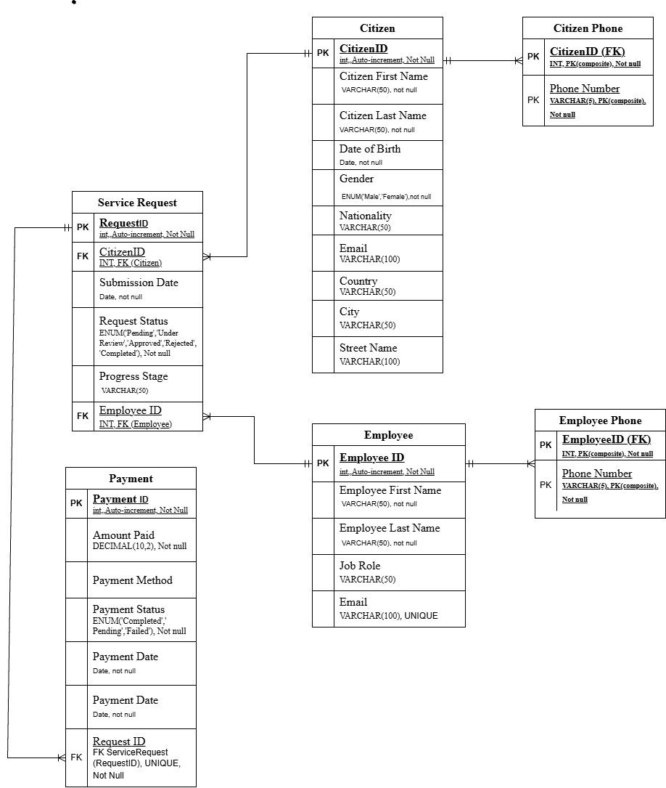

The physical design of the database translates the logical schema into an actual implementation within a specific database management system, in this case, MySQL. It defines how data is stored in tables, how indexes are applied for faster retrieval, and how relationships are enforced through primary and foreign keys at the storage level. In this design, the Citizen and CitizenPhone tables are implemented with proper indexing on CitizenID to optimize search and join operations, while the Employee and EmployeePhone tables use indexes on EmployeeID for efficient access. The ServiceRequest table includes foreign keys referencing CitizenID and EmployeeID, ensuring referential integrity and enabling quick lookups of requests by citizen or assigned employee. The Payment table enforces a (1:M) relationship with ServiceRequest through a foreign key (RequestID), allowing multiple payment records to reference the same service request while preserving referential integrity. Constraints such as NOT NULL, UNIQUE, and CHECK are applied to relevant columns to maintain data accuracy and enforce business rules. Overall, the physical design ensures that the database performs efficiently, preserves data integrity, and accurately reflects the relationships and rules defined in the logical model.

Effectiveness of the design
- Selection of Entities and Attributes
My database consists of four main entities: Citizen, Employee, ServiceRequest, and Payment.

- The Citizen entity stores all essential information for identifying and communicating with users of the SANAD Personal ID Renewal service. Attributes include CitizenID, First Name, Last Name, Date of Birth, Gender, Nationality, Email, Country, City, Street Name, and phone numbers (handled via a separate CitizenPhone table to accommodate multiple numbers).
- The Employee entity manages system operations, including processing service requests. It includes EmployeeID, First Name, Last Name, Job Role, Email, and phone numbers (managed in a separate EmployeePhone table).
- The ServiceRequest entity tracks the renewal requests submitted by citizens. It includes RequestID, SubmissionDate, RequestStatus, ProgressStage, and foreign keys linking to the submitting Citizen and the responsible Employee.
- The Payment entity ensures accurate tracking of payments associated with each service request. Attributes include PaymentID, AmountPaid, PaymentMethod, PaymentDate, PaymentStatus, and a foreign key referencing the related ServiceRequest.
This selection ensures the system manages citizens, employees, service requests, and payments effectively, covering all critical operations from registration to service completion.

- Establishment of Relationships
The database relationships reflect real-world workflows:
- Citizen – ServiceRequest (1:M): A citizen can submit multiple service requests, and each request is linked to a single citizen. This allows tracking all requests per citizen.
- Employee – ServiceRequest (1:M): An employee can process many service requests, ensuring accountability and workflow management.
- ServiceRequest – Payment (1:M): A service request may be associated with multiple payment records, allowing flexibility in payment processing while ensuring each payment belongs to a valid service request.
- CitizenPhone and EmployeePhone (1:M): These handle multi-valued phone numbers, ensuring accurate contact information without redundancy.
These relationships maintain data integrity, ensure accurate representation of real-world interactions, and allow efficient querying for reporting or auditing purposes.

- Conceptual Design and Its Intended Audience
The conceptual design provides a high-level view of system entities and their interactions, making it easier for project managers, developers, and stakeholders to understand the system requirements and relationships without needing technical details. It simplifies complex workflows such as payment validation, request processing, and employee assignment.

- Schema Creation and Its Importance
The schema enforces relational structure, defining primary keys (e.g., CitizenID, RequestID) and foreign keys to maintain relationships. This ensures consistency, referential integrity, and prevents orphaned records. The schema also facilitates integration and expansion if additional SANAD services are incorporated in the future.

- Logical Design Specifications
Normalization up to 3NF eliminates redundancy and anomalies. Multi-valued attributes (like phone numbers) are separated into their own tables. Composite attributes (like full name or address) are split into atomic components. Foreign keys define relationships, supporting complex queries such as listing all pending service requests for a specific employee or retrieving all payments for a citizen. This phase ensures reliability and accuracy in day-to-day operations.

- Physical Design Enhancements
The physical design specifies data types (integers for IDs, VARCHAR for names and emails, DATE for dates) and indexes on primary and foreign keys for efficient retrieval. Constraints like NOT NULL, UNIQUE, and CHECK enforce data validity. Backup and recovery strategies ensure data security and continuity, supporting the organization’s need for a reliable system.

- Conclusion
By integrating careful entity selection, normalization, relationship mapping, and physical optimization, the database meets all user and system requirements. It enables citizens to submit requests and track progress, employees to manage and update requests efficiently, and administrators to maintain oversight, while ensuring data integrity, scalability, and security. This design provides a robust foundation for the SANAD Personal ID Renewal system and can be extended for other digital government services in the future.

References
- Al-Fedaghi, S. (2021) Conceptual Data Modeling: Entity-Relationship Models as Thinging Machines. arXiv, 29 September 2021. Available at: https://arxiv.org/abs/2109.14717 (Accessed: date).

- Elmasri, R. and Navathe, S. (2010) Fundamentals of Database Systems. Pearson a standard textbook covering ER modeling, schema design, and normalization.

- Silberschatz, A., Korth, H. and Sudarshan, S. (2019) Database System Concepts. McGraw-Hill overview of logical design, normalization principles and data integrity.

- Database Design Concepts (2025) Database Design Concepts. Udayarumilli.com database design principles including entities/relationships and normalization. Available at: https://udayarumilli.com/database-design-concepts/ (Accessed: date).

- Principle of Orthogonal Design (2025) Principle of orthogonal design. Wikipedia — explains design principles to reduce redundancy and ensure logical consistency in relational databases. Available at: https://en.wikipedia.org/wiki/Principle_of_orthogonal_design (Accessed: date).

- Enhanced Entity–Relationship Model (2025) Enhanced entity–relationship model. Wikipedia extends basic ER modeling with richer semantic constructs for complex designs. Available at: https://en.wikipedia.org/wiki/Enhanced_entity%E2%80%93relationship_model (Accessed: date).

- YouTube. (2026) [Learn Database Normalization]. Available at: https://www.youtube.com/watch?v=GFQaEYEc8_8 (Accessed: 21‏ November 2021).

